

**Information Technology University (ITU)**

Software Requirement Specification  
(SRS DOCUMENT)

for

**Hair Rescue Hub**  
Version 1.0

***By***

**M.Abubakar Saif BSCE21017**

**Saud Sohail BSCE21022**

**Musa Zaheer BSCE21037**

***Supervisor*Dr Usman Younis**

***Co-Supervisor*Ayesha Aman**

*Bachelor of Science in Computer Engineering(2021-2025)*

**Table of Contents**

1. Introduction 1

1.1 Purpose 1

1.2 Scope 1

1.3 Modules 1

2. Overall Description 1

2.1 Product Perspective 1

2.2 User classes and characteristics 1

2.3 Operating Environment 1

2.4 Design and Implementation Constraints 2

3. Requirement Identifying Technique 2

4. Functional Requirements 2

4.1 Feature <ID: Title> /Use case <ID: Title> 3

4.1.1 Functional Requirement <ID: Title> 3

5. Non-Functional Requirements 3

5.1 Reliability 4

5.2 Usability 4

5.3 Performance 4

5.4 Security 4

6. External Interface Requirements 4

6.1 User Interfaces Requirements 4

6.2 Software interfaces 5

6.3 Hardware interfaces 5

6.4 Communications interfaces 5

7. References 6

# Introduction

Hair loss and related concerns affect a significant portion of the global population, with more than 80% of men and nearly half of women experiencing significant hair loss during their lifetime. Despite the prevalence of these issues, finding a comprehensive and personalized solution remains a challenge. Hair loss can have profound emotional and social impacts, leading to decreased self-esteem, social anxiety, and even affecting one's professional image and success, especially in appearance-conscious fields.

In response to these challenges, we are introducing "Hair Rescue Hub," an innovative application aimed at addressing hair-related problems. Hair Rescue Hub goes beyond traditional treatments by providing a holistic approach to hair care. Through a combination of expert guidance, personalized solutions, and user-friendly features, Hair Rescue Hub empowers individuals to take control of their hair health effectively.

## Purpose

The purpose of "Hair Rescue Hub" is to provide a comprehensive and personalized solution to address hair-related problems effectively. By offering expert guidance, personalized solutions, and user-friendly features, the application aims to empower individuals to regain control over their hair health and overcome the emotional and social challenges associated with hair loss. Through innovative approaches and accessible resources, Hair Rescue Hub seeks to improve the overall well-being and confidence of its users.

## Scope

The scope of "Hair Rescue Hub" encompasses a wide range of features and functionalities aimed at addressing various hair-related concerns comprehensively. This includes providing expert guidance, personalized solutions, and user-friendly features to empower individuals in managing and improving their hair health. Additionally, the application will offer resources such as tips, tutorials, treatment schedules, home remedies, and real-time feedback through an AI chatbot. The scope also extends to facilitating video consultations with healthcare professionals, enhancing accessibility and convenience for users seeking expert advice. Overall, Hair Rescue Hub aims to cater to the diverse needs of individuals experiencing hair loss or related issues, ensuring a holistic approach to hair care within a unified platform.

## Modules

Discover the diverse range of modules within Hair Rescue Hub, each meticulously designed to cater to your specific hair care needs and empower you on your journey to healthier, more vibrant hair. Our system will have:

* Expert Guidance
* Personalized Solutions
* User-Friendly Features
* Educational Resources
* Real-Time Feedback
* Treatment Schedule
* Video Consultations
* Community Engagement
* Data Management
* Integration

# Overall Description

This section presents a high-level overview of the product and the environment in which it will be used, the anticipated users, and known constraints, assumptions, and dependencies.

## Product Perspective

Describe the product’s context and origin. Is it the next member of a growing product line, the next version of a mature system, a replacement for an existing application, or an entirely new product? Consider including visual models such as a context diagram to show the product’s relationship to other systems. See Appendix A for an example of context diagram.

## User classes and characteristics

Identify the various user classes that you anticipate will use this product, and describe their pertinent characteristics. See Appendix A for an example of how to present user classes and charateristics.

## Operating Environment

Describe the environment in which the software will operate, which might include the hardware platform; operating systems and versions; geographical locations of users, servers, and databases; and organizations that host the related databases, servers, and websites.

Example:

***OE-1:****The System shall operate correctly with the following web browsers: Windows Internet Explorer versions 7, 8, and 9; Firefox versions 12 through 26; Google Chrome (all versions); and Apple Safari versions 4.0 through 8.0.*

## Design and Implementation Constraints

There are times when a certain programming language must be used, a code library that has already had time invested to develop it needs to be used, and so forth. Describe any factors that will restrict the options available to the developers and the rationale for each constraint. Constraints are described further in Chapter 14[1], “Beyond functionality.”

Example:

*CON-1: The system shall use the current corporate standard Oracle database engine*

*CON-2: The application must use Microsoft .NET framework 4.5.*

*CON-3: Online payments may be made only through PayPal.*

*CON-3: All textual data used by the application shall be stored in the form of XML files.*

# Requirement Identifying Technique

This section describes the requirements identifying technique(s) which further help to derive functional requirements specification. The selection of the technique(s) will depend on the type of project. For instance,

* **Use case (use case diagram + detail use case)** is an effective technique for interactive end-user applications.
* **Event- response table** is for real-time system in which most of the functionalities are performed at backend.
* **Storyboarding** for graphically intensive applications.

Examples of above techniques are given in Appendix A

# Functional Requirements

This section describes the functional requirements of the system expressed in the natural language style. This section is typically organized by feature as a system feature name and specific functional requirements associated with this feature. It is just one possible way to arrange them. Other organizational options include arranging functional requirements by use case, process flow, mode of operation, user class, stimulus, and response depend on what kind of technique has been used to understand functional requirements. Hierarchical combinations of these elements are also possible, such as use cases within user classes. For further detail see Chapter 10 “Documenting the requirements”. Let consider the feature scheme as an example.

## Feature <ID: Title> /Use case <ID: Title>

Provide the feature details or the use case description through which the following set of functional requirements are mapped and derived.

## Functional Requirement <ID: Title>

Itemize the specific functional requirements associated with each feature. These are the software capabilities that must be implemented for the user to carry out the feature’s services or to perform a use case. Describe how the product should respond to anticipated error conditions and to invalid inputs and actions. Uniquely label each functional requirement, as described earlier. You can create multiple attributes for each functional requirement, such as source , rationale, business rule, dependencies, etc.

Note: Use any of these attributes to support the understanability and completeness of the functional requirement, where it is required.

The following template is required to write functional requirements. For further detail see Chapter 11” Writing excellent requirements”.

|  |  |
| --- | --- |
| **Identifier** | FR-1 |
| **Title** | Title of requirement |
| **Requirement** | Description of requirement which may be written either from the user or system perspective e.g.  If written in a **user perspective**  The [user class or actor name] shall be able to [do something] [to some object] [qualifying conditions, response time, or quality statement].  If written in a **system perspective**  [optional precondition] [optional trigger event] the system shall [expected system response] |
| **Source** | Where this requirement comes from (who originate it) |
| **Rationale** | The motivation behind the requirement |
| **Business Rule** | Any restriction, policy, the rule that the particular requirement must be fulfilled through its functional behavior |
| **Dependencies** | Requirements ID that is dependent on this requirement |
| **Priority** | High/Medium/Low |

# Non-Functional Requirements

This section specifies nonfunctional requirements other than constraints, which are recorded in section 2.3, and external interface requirements, which will appear in section 7. These quality requirements should be specific, quantitative, and verifiable. Chapter 14 “beyond functionality” presents more information about these quality attribute requirements and many examples. The following are some examples of documenting guidelines.

## Reliability

Requirements about how often the software fails. The measurement is often expressed in MTBF (mean time between failures). The definition of a failure must be clear. Also, don't confuse reliability with availability which is quite a different kind of requirement.  Be sure to specify the consequences of software failure, how to protect from failure, a strategy for error detection, and a strategy for correction.

## Usability

Usability requirements deal with ease of learning, ease of use, error avoidance and recovery, the efficiency of interactions, and accessibility. The usability requirements specified here will help the user interface designer create the optimum user experience.

Example:

*USE-1: The COS shall allow a user to retrieve the previous meal ordered with a single interaction.*

## 

## Performance

State specific performance requirements for various system operations. If different functional requirements or features have different performance requirements, it’s appropriate to specify those performance goals right with the corresponding functional requirements, rather than collecting them in this section.

Example:

*PER-1: 95% of webpages generated by the COS shall download completely within 4 seconds from the time the user requests the page over a 20 Mbps or faster Internet connection.*

## Security

One or more requirements about protection of your system and its data. The measurement can be expressed in a variety of ways (effort, skill level, time, ...) to break into the system.  Do not discuss solutions (e.g. passwords) in a requirements document.

# External Interface Requirements

This section provides information to ensure that the system will communicate properly with users and with external hardware or software elements. A complex system with multiple subcomponents should create a separate interface specification or system architecture specification. The interface documentation could incorporate material from other documents by reference. For instance, it could point to a hardware device manual that lists the error codes that the device could send to the software.

## User Interfaces Requirements

Describe the logical characteristics of each user interface that the system needs. Some possible items to include are

* References to GUI standards or product family style guides that are to be followed.
* Standards for fonts, icons, button labels, images, color schemes, field tabbing sequences, commonly used controls, and the like.
* Screen layout or resolution constraints.
* Standard buttons, functions, or navigation links that will appear on every screen, such as a help button.
* Shortcut keys.
* Message display conventions.
* Layout standards to facilitate software localization.
* Accommodations for visually impaired users.

Document the user interface design details, such as specific dialog box layouts, in a separate user interface specification, not in the SRS. Including screen mock-ups in the SRS to communicate another view of the requirements is helpful but make it clear that the mock-ups are not the committed screen designs. If the SRS is specifying an enhancement to an existing system, it sometimes makes sense to include screen displays exactly as they are to be implemented. The developers are already constrained by the current reality of the existing system, so it's possible to know up front just what the modified, and perhaps the new, screens should look like.

## Software interfaces

Describe the connections between this product and other software components (identified by name and version), including other applications, databases, operating systems, tools, libraries, websites, and integrated commercial components (If any).

Example:

SI-1: Cafeteria Inventory System

*SI-1.1: The COS shall transmit the quantities of food items ordered to the Cafeteria Inventory System through a programmatic interface*.

## Hardware interfaces

Describe the characteristics of each interface between the software components and hardware components, if any, of the system. This description might include the supported device types, the data and control interactions between the software and the hardware, and the communication protocols to be used. For more about specifying requirements for systems containing hardware, see Chapter 26, “Embedded and other real-time systems projects.”

## Communications interfaces

State the requirements for any communication functions the product will use, including email, web browser, network protocols, and electronic forms.

Example:

*CI-1: The COS shall send an email or text message (based on user account settings) to the Patron to confirm acceptance of an order, price, and delivery instructions.*

# References

List any documents or other resources to which this SRS refers, if any. These might include user interface style guides, standards, system requirements specifications, interface specifications, or the SRS for a related product. The following are a few examples of different resources.

**Book**

Author(s). Book title. Location: Publishing company, year, pp.

Example:

W.K. Chen. Linear Networks and Systems. Belmont, CA: Wadsworth, 1993, pp. 123-35.

**Article in a Journal**

Author(s). “Article title”. Journal title, vol., pp, date.

Example:

G. Pevere. “Infrared Nation.” The International Journal of Infrared Design, vol. 33, pp. 56-99, Jan. 1979.

**Articles from Conference Proceedings (published)**

Author(s). “Article title.” Conference proceedings, year, pp.

Example:

D.B. Payne and H.G. Gunhold. “Digital sundials and broadband technology,” in Proc. IOOC-ECOC, 1986, pp. 557-998.

**World Wide Web**

Author(s)*. “Title.” Internet: complete URL, date updated* [date accessed].

M. Duncan. “Engineering Concepts on Ice. Internet: www.iceengg.edu/staff.html, Oct. 25, 2000 [Nov. 29, 2003].

**Appendix A**

**Example: Context Diagram**

The Cafeteria Ordering System is a new software system that replaces the current manual and telephone processes for ordering and picking up meals in the Process Impact cafeteria. The context diagram in Figure A-1 illustrates the external entities and system interfaces.

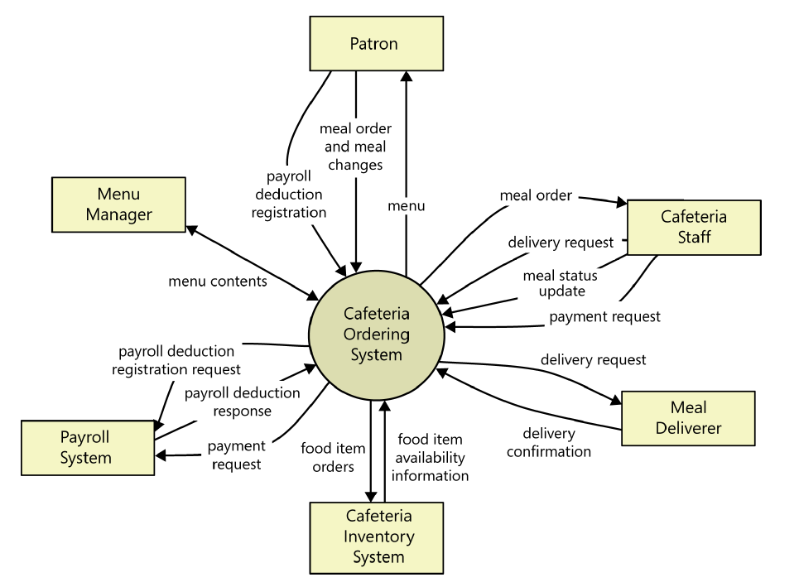

Figure A-1: Context diagram of the Cafeteria Ordering System.

**Example: User Classes and Characteristics**

Table A-1 Shows user classes and characteristic for Cafetaria ordering system

|  |  |
| --- | --- |
| **User class** | **Description** |
| **Patron** | A Patron is a Process Impact employee who wants to order meals to be delivered from the company cafeteria. There are about 600 potential Patrons, of which 300 are expected to use the COS an average of 5 times per week each. Patrons will sometimes order multiple meals for group events or guests. An estimated 60 percent of orders will be placed using the corporate intranet, with 40 percent of orders being placed from home or by smartphone or tablet apps. |
| **Cafeteria Staff** | The Process Impact cafeteria employs about 20 Cafeteria Staff who will receive orders from the COS, prepare meals, package them for delivery, and request delivery. Most of the Cafeteria Staff will need training in the use of the hardware and software for the COS. |
| **Menu Manager** | The Menu Manager is a cafeteria employee who establishes and maintains daily menus of the food items available from the cafeteria. Some menu items may not be available for delivery. The Menu Manager will also define the cafeteria’s daily specials. The Menu Manager will need to edit existing menus periodically. |
| **Meal Deliverer** | As the Cafeteria Staff prepare orders for delivery, they will issue delivery requests to a Meal Deliverer’s smartphone. The Meal Deliverer will pick up the food and deliver it to the Patron. A Meal Deliverer's other interactions with the COS will be to confirm that a meal was (or was not) delivered. |

**Example: Use case Diagram**

Following use case diagram is of an appointment system in which all the use case diagram relationships are presented. In further in **Table A-2** to the detail of use case diagram sytax is provided.

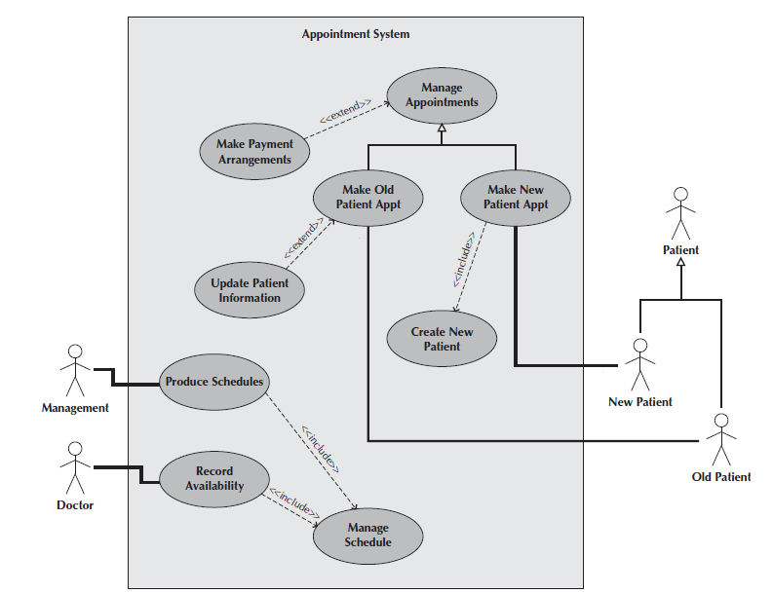

Figure A-2: Use Case Diagram of an Appointment System

**Syntax for Use case Diagram**

Table A-2 Syntax for Use case Diagram

|  |  |
| --- | --- |
| **An actor:**  ■ Is a person or system that derives benefit from and is external to the subject.  ■ Is depicted as either a stick figure (default) or, if a nonhuman actor is involved, a  rectangle with <<actor>> in it (alternative).  ■ Is labeled with its role.  ■ Can be associated with other actors using a specialization/superclass association,  denoted by an arrow with a hollow arrowhead.  ■ Is placed outside the subject boundary. |  |
| **A use case:**  ■ Represents a major piece of system functionality.  ■ Can extend another use case.  ■ Can include another use case.  ■ Is placed inside the system boundary.  ■ Is labeled with a descriptive verb–noun phrase. |  |
| **subject boundary:**  ■ Includes the name of the subject inside or on top.  ■ Represents the scope of the subject, e.g., a system or an individual  business process. |  |
| **An association relationship:**  ■ Links an actor with the use case(s) with which it interacts. |  |
| **An include relationship:**  ■ Represents the inclusion of the functionality of one use case within another.  ■ Has an arrow drawn from the base use case to the used use case. |  |
| **An extend relationship:**  ■ Represents the extension of the use case to include optional behavior.  ■ Has an arrow drawn from the extension use case to the base use case. |  |
| **A generalization relationship:**  ■ Represents a specialized use case to a more generalized one.  ■ Has an arrow drawn from the specialized use case to the base use case. |  |

**Detail Use Case Example**

The below indicate a comprehensive use case template filled in with an example drawn from the Cafeteria ordering system (COS).

**UC-1: Order a Meal**

[Provide a brief description of the reason for and outcome of this use case.] e.g.

In this use case a Patron accesses the Cafeteria Ordering System from either the corporate intranet or external Internet, views the menu for a specific date, selects food items, and places an order for a meal to be picked up in the cafeteria or delivered to a specified location within a specified 15-minute time window

|  |  |  |  |  |  |
| --- | --- | --- | --- | --- | --- |
| **Actors:** | [An actor is a person or other entity external to the software system being specified who interacts with the system and performs use cases to accomplish tasks.] e.g.   |  |  |  |  | | --- | --- | --- | --- | | Primary Actor: | Patron | Secondary Actors: | Cafeteria Inventory System | |
| **Trigger:** | [Identify the event that initiates the use case.]e.g.  A Patron indicates that he wants to order a meal. |
| **Preconditions:** | [List any activities that must take place, or any conditions that must be true, before the use case can be started.  PRE-1. Patron is logged into COS.  PRE-2. Patron is registered for meal payments by payroll deduction. |
| **Postconditions:** | [Describe the state of the system at the conclusion of the use case execution.  POST-1. Meal order is stored in COS with a status of “Accepted.”  POST-2. Inventory of available food items is updated to reflect items in this order.  POST-3. Remaining delivery capacity for the requested time window is updated. |
| **Normal Flow:** | [Provide a detailed description of the user actions and system responses that will take place during execution of the use case under normal, expected conditions.  1.0 Order a Single Meal  1. Patron asks to view menu for a specific date. (see 1.0. E1, 1.0.E2)  2. COS displays menu of available food items and the daily special.  3. Patron selects one or more food items from menu. (see 1.1)  4. Patron indicates that meal order is complete. (see 1.2)  5. COS displays ordered menu items, individual prices, and total price, including taxes and delivery charge.  6. Patron either confirms meal order (continue normal flow) or requests to modify meal order (return to step 2).  7. COS displays available delivery times for the delivery date.  8. Patron selects a delivery time and specifies the delivery location.  9. Patron specifies payment method.  10. COS confirms acceptance of the order.  11. COS sends Patron an email message confirming order details, price, and delivery instructions.  12. COS stores order, sends food item information to Cafeteria Inventory System, and updates available delivery times. |
| **Alternative Flows:** | [Document legitimate branches from the main flow to handle special conditions (also known as extensions). For each alternative flow reference the branching step number of the normal flow and the condition which must be true for this extension to be executed. e.g.  1.1 Order multiple identical meals  1. Patron requests a specified number of identical meals. (see 1.1. E1)  2. Return to step 4 of normal flow.  1.2 Order multiple meals  1. Patron asks to order another meal.  2. Return to step 1 of normal flow.  Note: Insert a new row for each distinctive alternative flow. ] |
| **Exceptions:** | 1.0. E1 Requested date is today and current time is after today’s order cutoff time  1. COS informs Patron that it’s too late to place an order for today.  2a. If Patron cancels the meal ordering process, then COS terminates use case.  2b. Else if Patron requests another date, then COS restarts use case.  1.0. E2 No delivery times left  1. COS informs Patron that no delivery times are available for the meal date.  2a. If Patron cancels the meal ordering process, then COS terminates use case.  2b. Else if Patron requests to pick the order up at the cafeteria, then continue with normal flow, but skip steps 7 and 8.  1.1. E1 Insufficient inventory to fulfill multiple meal order  1. COS informs Patron of the maximum number of identical meals he can order, based on current available inventory.  2a. If Patron modifies number of meals ordered, then return to step 4 of normal flow.  2b. Else if Patron cancels the meal ordering process, then COS terminates use case. |
| **Business Rules** | Use cases and business rules are intertwined. Some business rules constrain which roles can perform all or parts of a use case. Perhaps only users who have certain privilege levels can perform specific alternative flows. That is, the rule might impose preconditions that the system must test before letting the user proceed. Business rules can influence specific steps in the normal flow by defining valid input values or dictating how computations are to be performed e.g.  BR-1 Delivery time windows are 15 minutes, beginning on each quarter hour.  BR-2 Deliveries must be completed between 11:00 A.M. and 2:00 P.M. local time, inclusive.  Note: If you are maintaining the business rule in a separate table in SRS then only mention here their IDs. |
| **Assumptions:** | [List any assumptions.   1. e.g. Assume that 15 percent of Patrons will order the daily special (Source: previous 6 months of cafeteria data). |

Event-Response Tables

In order to develop Event Response table fisrt it is required to identify all possible events. Following is an example of events list and event-response table of higway intersection system.

The highway intersection system described earlier has to deal with various events, including these:

* A sensor detects a car approaching in one of the through lanes.
* A sensor detects a car approaching in a left-turn lane.
* A pedestrian presses a button to request to cross a street.
* One of many timers counts down to zero.

**Table A-3** presents a fragment of what an event-response table might look like for such a system. Each expected system behavior consists of a combination of event, system state, and response.

**Note:** You may add more information to event-response table in order to perform detail requirement analysis which includes:

* The event frequency (how many times the event takes place in a given time period, or a limit to how many times it can occur).
* Data elements that are needed to process the event.
* The state of the system after the event responses are executed.

Table A-3 Partial Event-Response Table for a Highway Intersection

|  |  |  |
| --- | --- | --- |
| **Event** | **System State** | **Response** |
| Road sensor detects  vehicle entering left-turn  lane. | Left-turn signal is red. Cross-traffic signal is green. | Start green-to-amber  countdown timer for cross-traffic  signal. |
| Green-to-amber  countdown timer reaches  zero. | Cross-traffic signal is green. | 1. Turn cross-traffic signal amber.  2. Start amber-to-red countdown timer. |
| Amber-to-red  countdown timer reaches  zero. | Cross-traffic signal is amber. | 1. Turn cross-traffic signal red.  2. Wait 1 second.  3. Turn left-turn signal green.  4. Start left-turn-signal countdown timer. |
| Pedestrian presses a  specific walk-request  button. | Pedestrian sign is solid Don’t Walk.  Walk-request countdown timer is not activated. | Start walk-request countdown timer. |
| Pedestrian presses  walk-request button. | Pedestrian sign is solid Don’t Walk.  Walk-request countdown timer is activated. | Do nothing. |
| Walk-request  countdown timer reaches  zero plus the amber  display time. | Traffic signal in walk  direction is green. | Change all green traffic signals to amber. |
| Walk-request  countdown timer reaches  zero. | Traffic signal in walk  direction is amber. | 1. Change all amber traffic signals to red.  2. Wait 1 second.  3. Set pedestrian sign to Walk.  4. Start don’t-walk countdown timer. |

Story Boarding

Following is an example of story boarding which is use to identify and analyze graphically intensive applications.







1. Karl Wiegers and Joy Beatty, Software Requirements 3rd edition.

   Note: All the referenced chapters are selected from the above book